**LOW LEVEL STRUCTURAL DIAGRAM FOR SUBTRACTION (LL_02)**

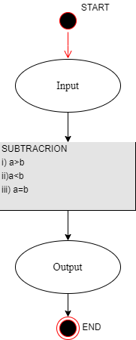

**LOW LEVEL BEHAVIORAL DIAGRAM FOR SUBTRACTION (LL_02)**

